# Exercise: Web Service Introduction

Problems for exercises and homework for the ["Back-End Technologies Basics"](https://softuni.bg/trainings/4726/back-end-technologies-basics-september-2024) Course @ SoftUni.

**Initial Instructions for Music App**

**Prerequisites**

Installed Docker: <https://www.docker.com/>

**Steps to Use Music App**

1. **Download the music-app.zip file**, which contains all the necessary files.

2. **Unzip the music-app.zip file** into your preferred directory on your machine.

3. **Build** and **Run** the Docker Containers.

Ensure you have Docker and Docker Compose installed.

Then, run the following command to build and start the containers:

**docker-compose up --build**

This command will load the Docker image into your local Docker environment.

4. **Access the API**

Once the containers are up and running, you can access the API at [**http://localhost:3030**](http://localhost:3030)

5. **API Documentation**

API documentation is available at [**http://localhost:3300/api-docs**](http://localhost:3300/api-docs)

You can [read the documentation here](https://github.com/softuni-practice-server/softuni-practice-server)

## Register a New User

1. **Locate POST /users/register :**

* In Swagger UI, find the section or tab that contains **POST /users/register**

1. **Expand POST /users/register :**

* Click on the **POST /users/register** method to expand the section and view the request form.

1. **Fill in the form:**

* Enter the required information for the new user:
  + **email**: user@example.com (or another valid email address)
  + **password**: password123 (or another password)

1. **Send the request:**

* Click the **Try it out** button and then click **Execute** to send the request to the server.

1. **Review the response:**

* Swagger UI will display the results of the request:
  + If successful (**status code 200**), you will see details of the new user.
    - Upon successful login or registration (**HTTP Status 200**), you will receive a **token** in the response.

* + - This token is required for **authenticating requests** to protected endpoints.
    - Please use this token to authorize your API requests.
  + If there is an error (**status code 400 or 409**), you will see the corresponding error message.

## Login a User

1. **Locate POST /users/login :**

* In Swagger UI, find the section or tab that contains **POST /users/login**

1. **Expand POST /users/login**

* Click on the **POST /users/login** method to expand the section and view the request form.

1. **Fill in the form:**

* Enter the login details:
  + **email**: user@example.com (or another valid email address)
  + **password**: password123 (or another password)

1. **Send the request:**

* Click the **Try it out** button and then click **Execute** to send the request to the server.

1. **Review the response:**

* Swagger UI will display the results of the request:
  + If successful (**status code 200**), you will see details of the new user.
    - Upon successful login or registration (**HTTP Status 200**), you will receive a **token** in the response.

* + - This token is required for **authenticating requests** to protected endpoints.
    - Please use this token to authorize your API requests.
  + If there is an error (**status code 403 or 500**), you will see the corresponding error message.

|  |
| --- |
| **How to Authenticate in Swagger UI?** Before making authenticated requests, ensure you have a user token. This token is obtained through the login or registration process.   * In Swagger UI, find the Authorize button. This button is usually located in the top-right corner of the Swagger UI interface.   A screenshot of a computer  Description automatically generated   * Click the Authorize button to open the authentication dialog. * In the dialog that appears, you will see an input field labeled "Value”. * Enter the user token you obtained during login or registration in this field.      * Click the Authorize button within the dialog to submit the token. * After submitting the token, close the authorization dialog.   Now you are authorized!  A screenshot of a cell phone  Description automatically generated |

## List All Albums

1. **Locate GET /data/albums :**

* Find the **GET /data/albums** endpoint in the **Music Library Albums** section.

1. **Expand GET /data/albums :**

* Click on the **GET /data/albums** method to reveal the request options.

1. **Add Query Parameter (optional):**

* If you want to sort albums, enter query parameter in the sortBy query parameter field.
  + The query parameter for the endpoint can be any of the **album properties**, such as **singer**, **album**, **imageUrl**, **label** or **sales**.
  + For instance, if you want to filter albums by the **artist's** **name**, you could use the **singer** query parameter.

1. **Send the request:**

* Click the **Try it out** button and then click **Execute** to send the request to the server.

1. **Review the response:**

* Swagger UI will display the results of the request:
  + If successful (**status code 200**), verify that the list of albums is displayed correctly.
  + If there is an error (**status code 400**), review the error message for details.

## Create a New Album

**Authentication Required: This endpoint requires a valid user token. Please ensure you are authenticated by providing a token obtained from the login or registration process.**

**1. Locate POST /data/albums :**

* Find the **POST /data/albums** endpoint in the **Music Library Albums** section

**2. Expand POST /data/albums :**

* Click on the **POST /data/albums** method to reveal the request options.

**3. Fill in the Request Body:**

* **Enter the details for the new album:** 
  + **singer: Artist Name**
  + **album: Album Title**
  + **imageUrl:** <http://example.com/image.jpg>
  + **label: Record Label**
  + **sales: 1000**

**4. Send the request:**

* Click the **Try it out** button and then click **Execute** to send the request to the server.

**5. Review the response:**

* Swagger UI will display the results of the request:
  + If successful (**status code 200**), verify that the new album details are correctly displayed.
  + If there is an error (**status code 401**), ensure that your authentication token is correct and retry.

## Get an Album by ID

**1. Locate GET /data/albums/{id} :**

* Find the **GET /data/albums/{id}** endpoint in the **Music Library Albums** section.

**2. Expand GET /data/albums/{id} :**

* Click on the **GET /data/albums/{id}** method to reveal the request form.

**3. Enter the Album ID:**

* **Input the ID of the album you wish to retrieve** **in the id path parameter field.**

**4. Send the request:**

* Click the **Try it out** button and then click **Execute** to send the request to the server.

**5. Review the response:**

* Swagger UI will display the results of the request:
  + If successful (**status code 200**), verify that the album details are correctly displayed.
  + If there is an error (**status code 404**), review the error message for details.

## Update an Album

**Authentication Required: This endpoint requires a valid user token. Please ensure you are authenticated by providing a token obtained from the login or registration process.**

**1. Locate PUT /data/albums/{id} :**

* Find the **PUT /data/albums/{id}** endpoint in the **Music Library Albums** section.

**2. Expand PUT /data/albums/{id} :**

* Click on the **PUT /data/albums/{id}** method to reveal the request form.

**3. Enter the Album ID:**

* **Input the ID of the album you wish to update in the id path parameter field.**

**4. Fill in the Request Body:**

* **Provide the updated album details:** 
  + **singer: Artist Name**
  + **album: Album Title**
  + **imageUrl:** <http://example.com/image.jpg>
  + **label: Record Label**
  + **sales: 1000**

**5. Send the request:**

* Click the **Try it out** button and then click **Execute** to send the request to the server.

**6. Review the response:**

* Swagger UI will display the results of the request:
  + If successful (**status code 200**), verify that the album details have been updated.
  + If there is an error (**status codes 401, 403, or 404**), review the error message for details.

## Delete an Album

**Authentication Required: This endpoint requires a valid user token. Please ensure you are authenticated by providing a token obtained from the login or registration process.**

**1. Locate DELETE /data/albums/{id} :**

* Find the **DELETE /data/albums/{id}** endpoint in the **Music Library Albums** section.

**2. Expand DELETE /data/albums/{id} :**

* Click on the **DELETE /data/albums/{id}** method to reveal the request form.

**3. Enter the Album ID:**

* **Input the ID of the album you wish to delete** **in the id path parameter field.**

**4. Send the request:**

* Click the **Try it out** button and then click **Execute** to send the request to the server.

**5. Review the response:**

* Swagger UI will display the results of the request:
  + If successful (**status code 200**), verify that the album has been deleted.
  + If there is an error (**status codes 401, 403, or 404**), review the error message for details.

By following these instructions, you will be able to thoroughly test the API and ensure it meets the required functionality and performance standards. Happy testing!

**Initial Instructions for Using SoftUni REST API**

For the solution of some of the following tasks, you will need to use an up-to-date version of the local REST service, provided in the lesson’s resources archive.

**Prerequisites**

Installed Docker: <https://www.docker.com/>

**Steps to Use SoftUni REST API**

1. **Download the softuni-rest-api.zip file**, which contains all the necessary files.

2. **Unzip the softuni-rest-api.zip file** into your preferred directory on your machine.

3. **Build** and **Run** the Docker Containers.

Ensure you have Docker and Docker Compose installed.

Then, run the following command to build and start the containers:

**docker-compose up --build**

This command will load the Docker image into your local Docker environment.

4. **Access the API**

Once the containers are up and running, you can access the API at [**http://localhost:3030**](http://localhost:3030)

You can [read the documentation here](https://github.com/softuni-practice-server/softuni-practice-server).

1. **REST Countries**

**NOTE: Install** "[Postman](https://www.getpostman.com/)" REST Client to **ease** your tasks.

* Manually compile an HTTP (as text) request for retrieving information about Bulgaria;
* Use Postman to make the same request;
* Make a request that retrieving only the fields name, capital, region, population for the country Italy.
* Make a request that takes all German-speaking countries.

Your first task is to get detailed information about Bulgaria.

* Send a "**GET**" request to the link given below.

**REQUEST**:

<https://restcountries.com/v2/name/Bulgaria>



**RESPONSE**:

Each API has documentation, where you can see how to use the API. You can find the documentation of this API here: <https://restcountries.com/>

* Now try to filter only specific fields of the information about Italy. Send a GET request with the needed parameter to get a response only with this information about the country:
* name, capital, region and population;

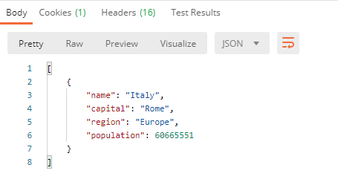

* There is a way to get a response holding all the countries, which citizens speak the German language. Send a GET request to become the information for these countries (Austria, Belgium, Germany, Holy See, Liechtenstein, Luxembourg, Switzerland), but filter the response to have only their names and region.

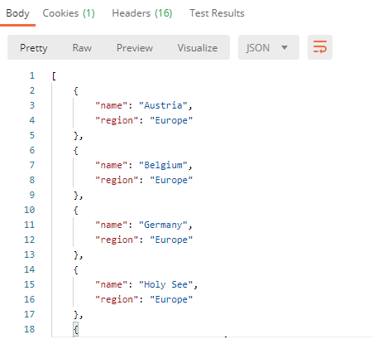

## Bus Stop

Perform an HTTP request that displays arrival times for all buses by a given bus stop ID.

* GET: <http://localhost:3030/jsonstore/bus/businfo/:stopID>

You will receive a JSON object in the format:

stopID: {

name: stopName,

buses: { busId: time, … }

}

### Hints

The webhost will respond with valid data to IDs 1287, 1308, 1327 and 2334.

## Phonebook GET

Perform an HTTP request that show people’s names, their phones and _id.

GET requests: <http://localhost:3030/jsonstore/phonebook>

## Phonebook POST

Create two different requests with **POST** request in Postman. The data sent in a POST request should be a valid JSON object, containing properties person and phone. Example format:   
{

"person": "<person>",

"phone": "<phone>"  
}

**POST:** [**http://localhost:3030/jsonstore/phonebook**](http://localhost:3030/jsonstore/phonebook)

## Employees

Use the link below to get, post, put and delete request in Postman. Send five types of requests supported by the API.

<https://dummyjson.com/>

* **GET REQUEST**

Get all posts data and single post data

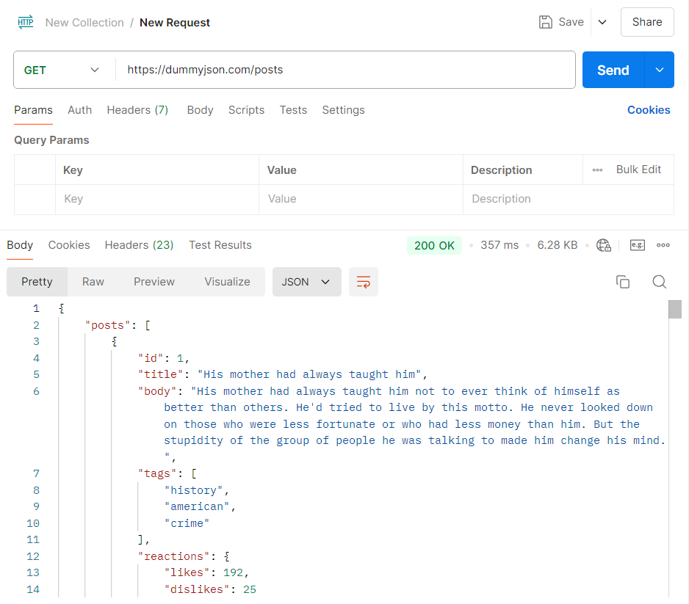

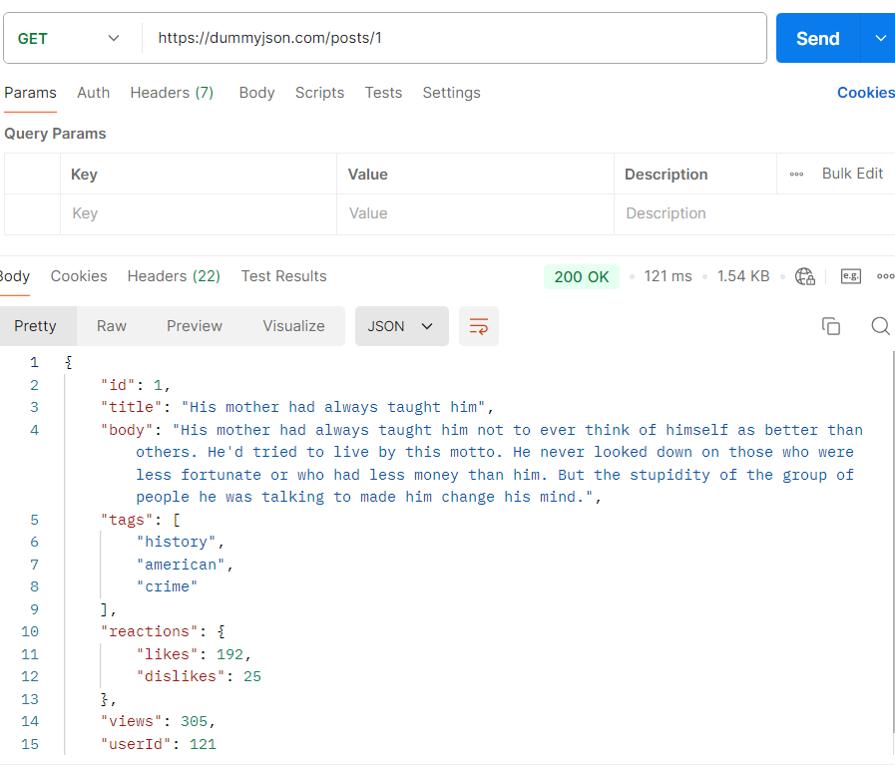

* **POST REQUEST**

Add new post

You can get some user ID from here <https://dummyjson.com/users>

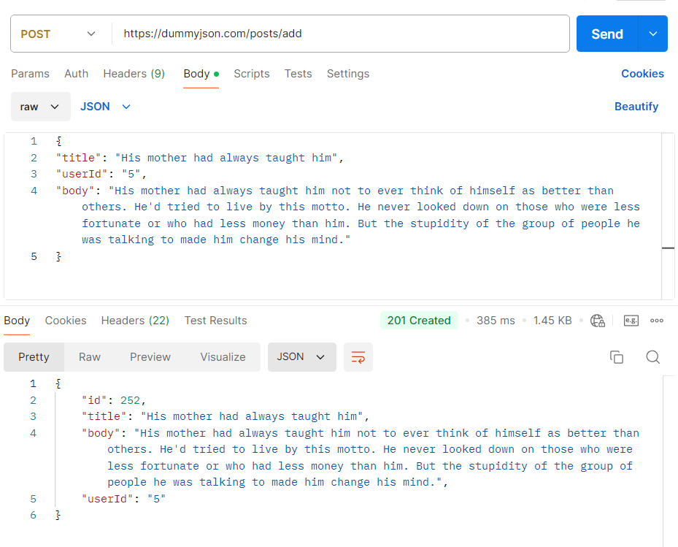

* **PUT/PATCH REQUEST**

Update the title of post with ID 1

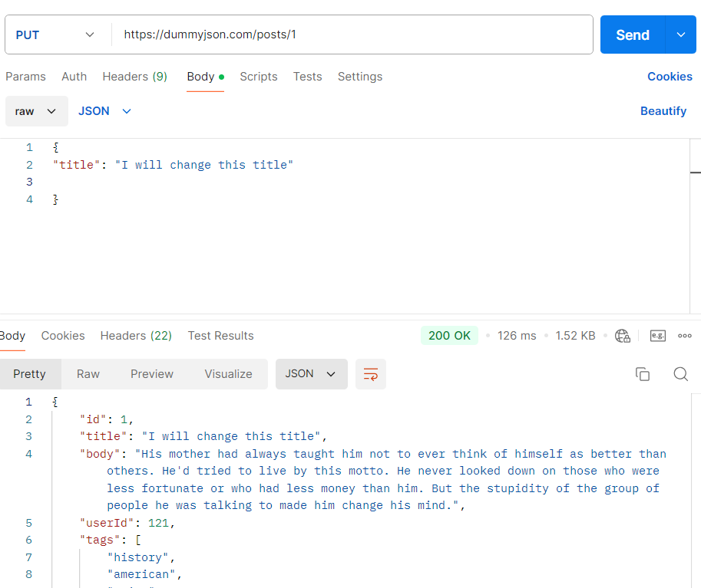

* **DELETE REQUEST**

Delete post with ID 1

Deleting a post will not delete it into the server.  
It will simulate a DELETE request and will return deleted post with isDeleted & deletedOn keys

